SIMATS ENGINEERING
Saveetha Institute of Medical and Technical Sciences

ASSESSMENT TOOL 3
Annexure A — Comparative Analysis
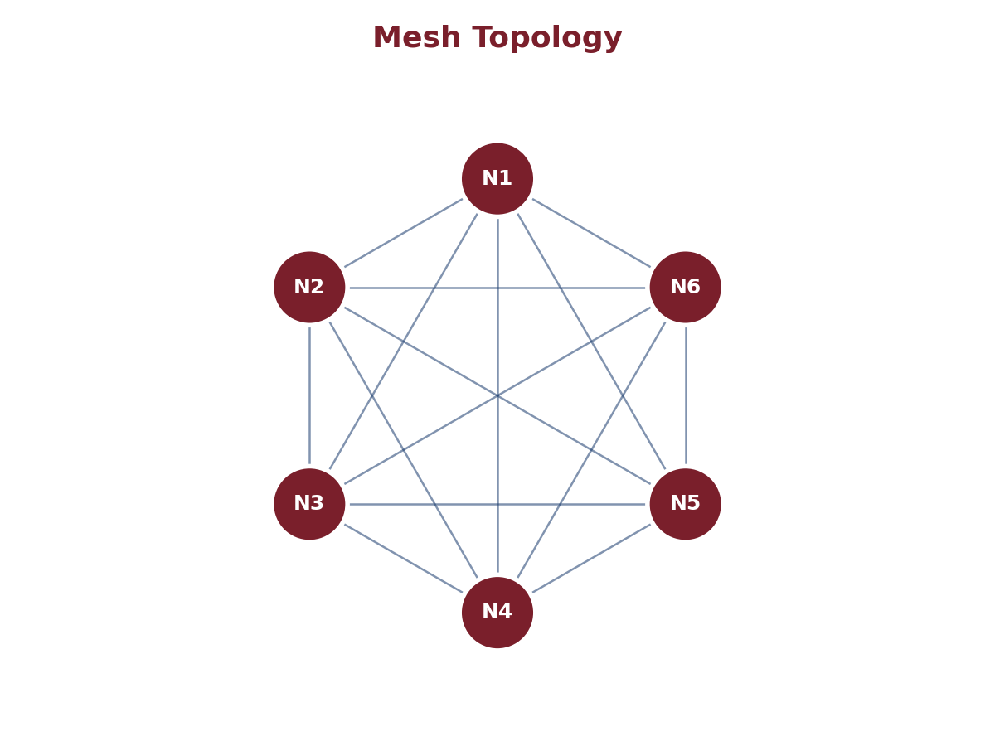

Student Name | Yuvashree (192511301)
Department | BE. CSE
Course Name | Computer Networks
Course Code | CSA07
Course Outcome | CO4 (BL2, BL6)
Assessment Tool | Assessment Tool 3 — Annexure A: Comparative Analysis
Weightage | 30%
Total Marks | 25

Course Outcome (CO4): Design network topologies — star, mesh, bus, and hybrid — using networking devices, transmission media, and cabling standards.
(Bloom's Levels: BL2, BL6)

Annexure A: Comparative Analysis
This annexure presents a comparative analysis of the star, bus, mesh, and hybrid network topologies covered under Course Outcome CO4, evaluated against parameters such as cost, reliability, performance, fault tolerance, installation complexity, scalability, and maintenance.
Question 1: Compare Star topology and Bus topology in terms of cost, reliability, and performance.
Answer:
Star topology is generally more expensive than bus topology because it requires a central device such as a switch or hub and more cabling to connect each node individually. In contrast, bus topology uses a single backbone cable, making it low-cost and easier to install. However, in terms of reliability, star topology is superior because failure of one node does not affect others, whereas a failure in the main bus cable can bring down the entire network. Performance is also better in star topology since data transmission is managed through a central device, reducing collisions, while bus topology suffers from performance degradation as more devices are added due to increased data traffic on the shared medium.
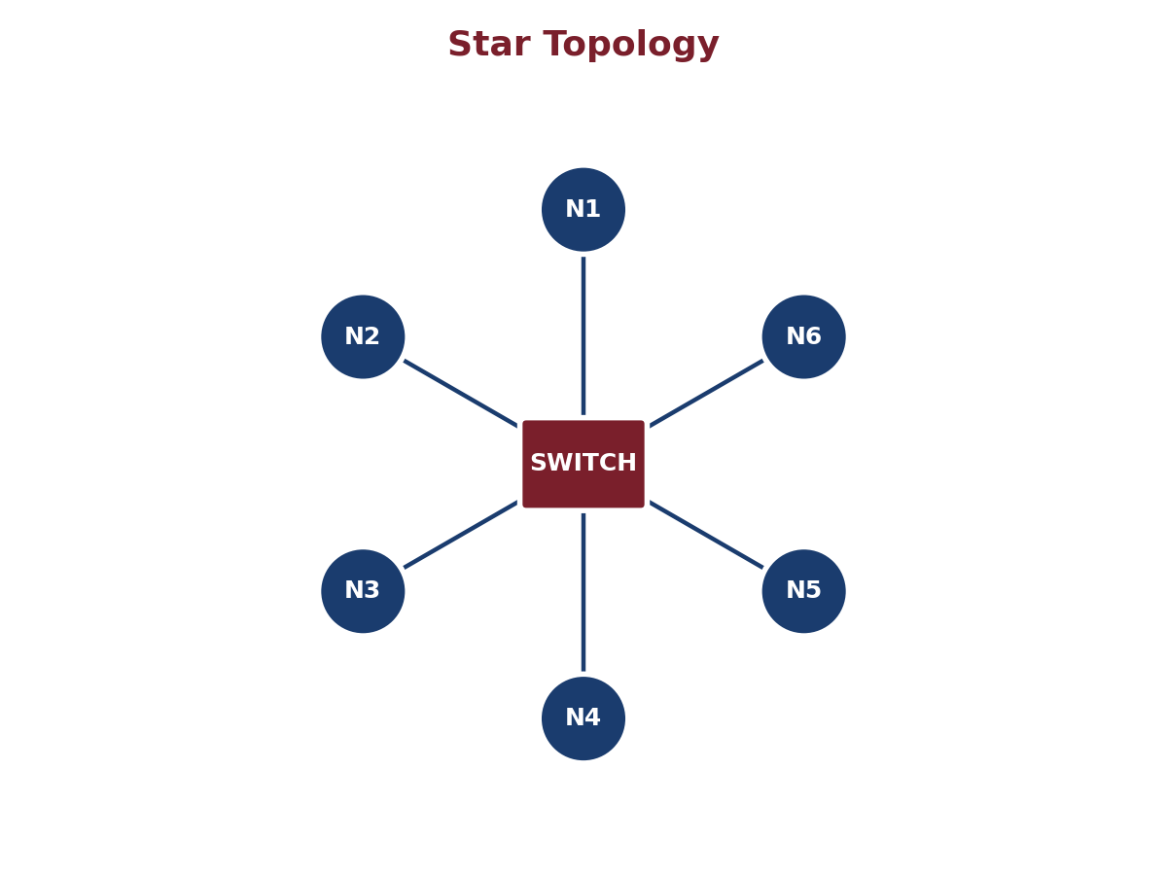
Fig. 1 — Star Topology: nodes individually cabled to a central switch/hub
Question 2: Compare Mesh topology and Star topology in terms of fault tolerance and reliability.
Answer:
Mesh topology offers very high fault tolerance because every node is connected to multiple other nodes, providing multiple paths for data transmission. If one link fails, data can still be routed through alternate paths without disrupting communication. In contrast, star topology has moderate fault tolerance; while failure of individual nodes does not affect the network, failure of the central hub or switch can cause the entire network to stop functioning. Therefore, mesh topology is more robust and reliable in critical environments compared to star topology.

Fig. 2 — Mesh Topology: every node interconnected, providing multiple alternate paths
Question 3: Compare Bus topology and Mesh topology in terms of installation complexity.
Answer:
Bus topology is simple and easy to install because it uses a single backbone cable with minimal connections, making it suitable for small networks. On the other hand, mesh topology is highly complex to install as each node must be connected to every other node, requiring a large number of cables and ports. This complexity increases significantly as the number of devices grows, making mesh topology time-consuming and costly to implement compared to the straightforward setup of bus topology.
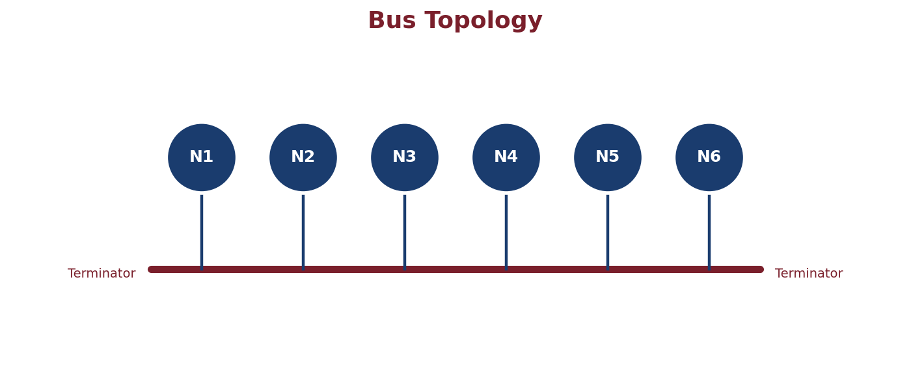
Fig. 3 — Bus Topology: single shared backbone cable with terminators at each end
Question 4: Compare Hybrid topology and Star topology in terms of scalability.
Answer:
Hybrid topology is highly scalable because it combines two or more different topologies (such as star, mesh, or bus), allowing the network to expand flexibly according to organizational needs. New segments can be added without affecting the existing network structure. In comparison, star topology is also scalable but to a limited extent, as it depends on the capacity of the central device (switch or hub). Once the central device reaches its port limit, expansion requires additional hardware. Thus, hybrid topology provides greater scalability than star topology.
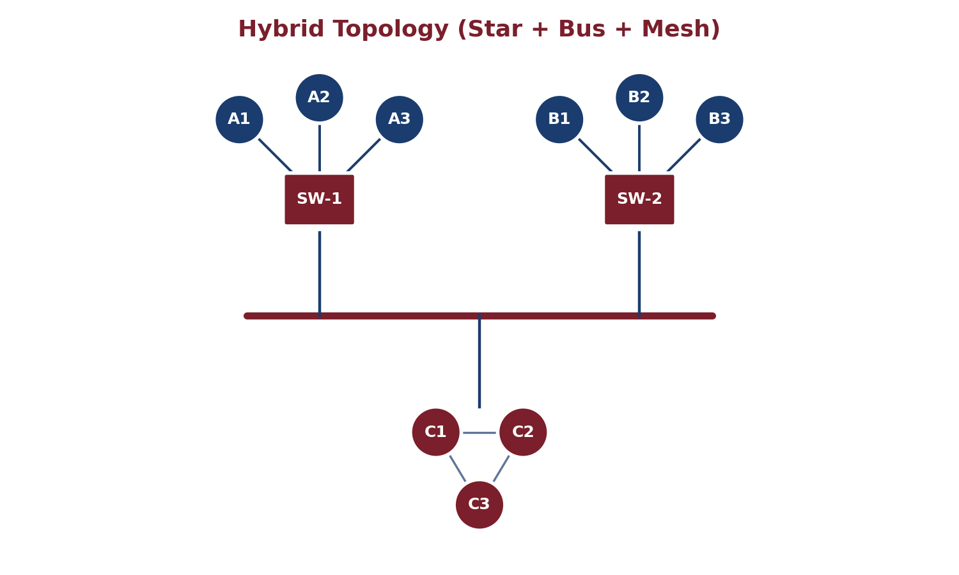
Fig. 4 — Hybrid Topology: a combination of star, bus, and mesh segments
Question 5: Compare Star, Mesh, Bus, and Hybrid topologies in terms of maintenance.
Answer:
In terms of maintenance, star topology is relatively easy to manage because issues can be quickly identified and isolated to a specific node or cable. Mesh topology, while highly reliable, is difficult to maintain due to its complex structure and large number of connections, making troubleshooting time-consuming. Bus topology is harder to maintain than star because faults in the backbone cable can disrupt the entire network and are difficult to locate. Hybrid topology has moderate maintenance complexity; while it benefits from flexibility, managing multiple combined topologies requires careful monitoring and skilled administration.

Rubrics for Calculation
The comparative analysis will be evaluated based on the following rubric criteria and weightage.
Criteria | Weight | Exemplary (4) | Proficient (3) | Developing (2) | Beginning (1)
Understanding of Concepts | 15% | Demonstrates complete and in-depth understanding of all concepts being compared | Good understanding with minor gaps | Basic understanding; some concepts unclear | Poor understanding of concepts
Comparison Depth | 20% | Provides detailed, insightful, and meaningful comparisons across multiple aspects | Adequate comparison with relevant points | Limited comparison; lacks depth | Minimal or incorrect comparison
Criteria Selection | 10% | Selects highly relevant and appropriate comparison parameters | Mostly relevant criteria | Some irrelevant or missing criteria | Poor or no criteria selection
Analytical Skills | 15% | Strong analysis with logical reasoning and clear justification | Good analysis with some justification | Basic analysis with weak reasoning | No clear analysis
Organization & Structure | 10% | Well-organized, clear, and logically structured | Generally organized | Somewhat disorganized | Poorly structured
Use of Examples / Evidence | 10% | Uses strong, relevant examples or data to support comparison | Uses some examples | Limited examples | No supporting examples
Clarity of Presentation | 10% | Very clear, concise, and easy to understand | Mostly clear | Somewhat unclear | Difficult to understand
Conclusion & Insights | 10% | Insightful conclusion with strong justification | Clear conclusion | Basic conclusion | No or weak conclusion

